Module 7 - Organizing Data and Visual Analytics in Tableau

7.1 K-Means Cluster Analysis
Definition
K-Means Clustering is a data analysis technique used to group similar data points into clusters. Tableau automatically groups data based on similarities in measures such as Sales, Profit, Quantity, etc.
It helps in:
- Customer segmentation
- Product performance analysis
- Regional analysis
- Identifying high and low-performing groups

Features of K-Means Clustering in Tableau
- Automatic grouping of marks
- Color-coded clusters
- Easy visualization
- Helps discover hidden patterns

Steps to Perform K-Means Cluster Analysis in Tableau
Dataset Used
Use the Global Superstore Dataset
Recommended fields:
- Sales
- Profit
- Quantity
- Discount

Step 1: Open Tableau
- Open Tableau Public/Desktop
- Connect to Global Superstore dataset

Step 2: Create Scatter Plot
Row Shelf
- Drag Sales
Column Shelf
- Drag Profit
Marks Card
- Drag Category to Color (optional)
This creates a scatter plot.

Step 3: Open Analytics Pane
- Click the Analytics tab (next to Data pane)
- Drag Cluster onto the view

Step 4: Configure Clusters
- Tableau automatically creates clusters
- To edit:
  - Right-click cluster legend
  - Select Edit Clusters
Options:
- Number of clusters
- Variables used
- Cluster names

Step 5: Analyze Results
Tableau groups similar points together.
Example:
- Cluster 1 → High Sales & High Profit
- Cluster 2 → Low Sales & Low Profit
- Cluster 3 → High Sales but Low Profit

K-Means Cluster Example
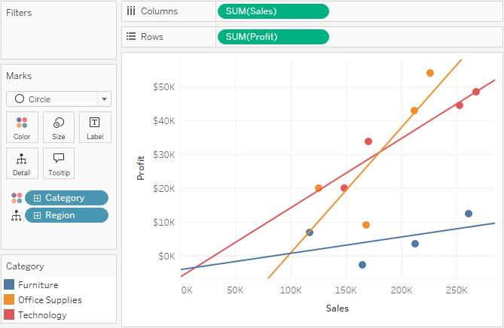
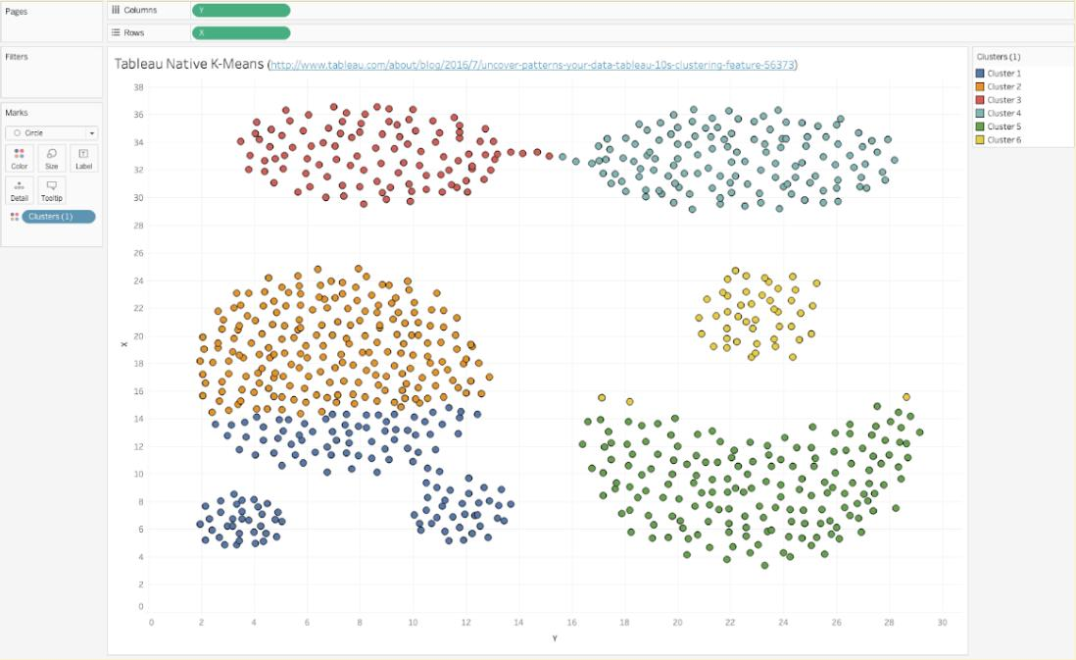
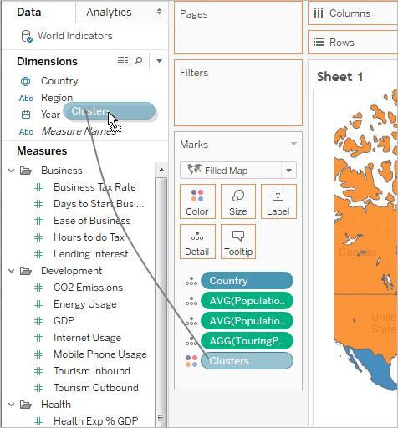
7

7.2 Trend and Reference Lines
Trend Line
Definition
Trend lines show the general direction of data over time.
Used for:
- Sales growth analysis
- Profit trends
- Forecast analysis

Steps to Add Trend Line
Step 1: Create Line Chart
Columns
- Order Date
Rows
- Sales

Step 2: Add Trend Line
- Open Analytics Pane
- Drag Trend Line into chart
- Select:
  - Linear
  - Logarithmic
  - Exponential
  - Polynomial

Step 3: View Trend Details
Right-click trend line → Describe Trend Model
You can see:
- R-squared value (How well data fits trend line, 0≤R2≤1)
- P-value (Whether trend is statistically significant, Is the relationship real or just random?, P<0.05 Relationship is significant, trustworthy or P>0.05 not be useful).
- Equation (Mathematical relationship between variables)
y=mx+c this equation helps predict future value, Estimate trends, Build forecasting models.

R² Value | Meaning
0 | No relationship
0.25 | Weak relationship
0.5 | Moderate relationship
0.75 | Strong relationship
1 | Perfect relationship

Trend Line Example
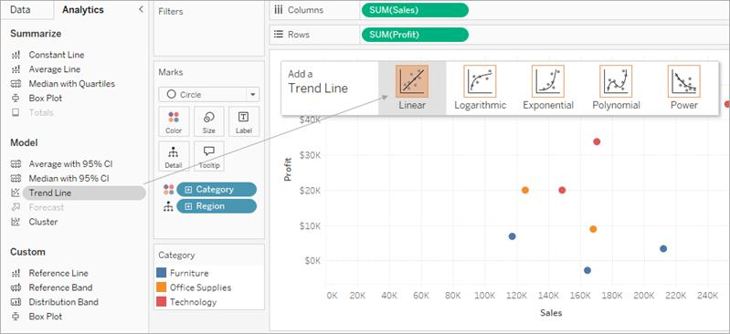
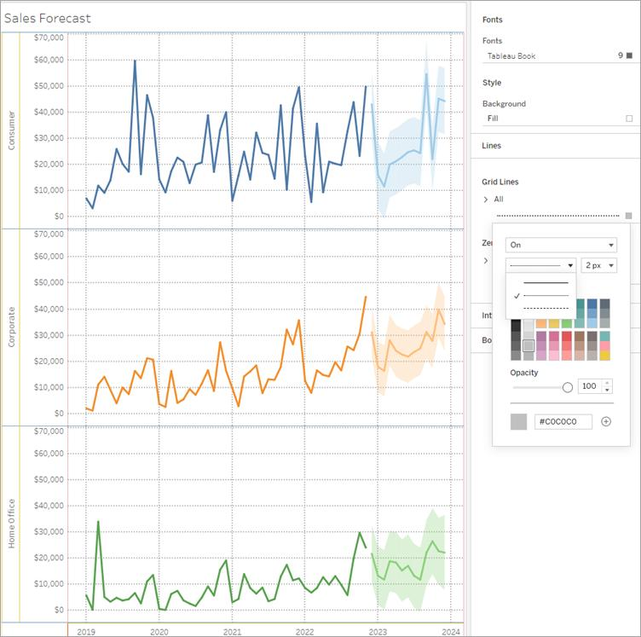
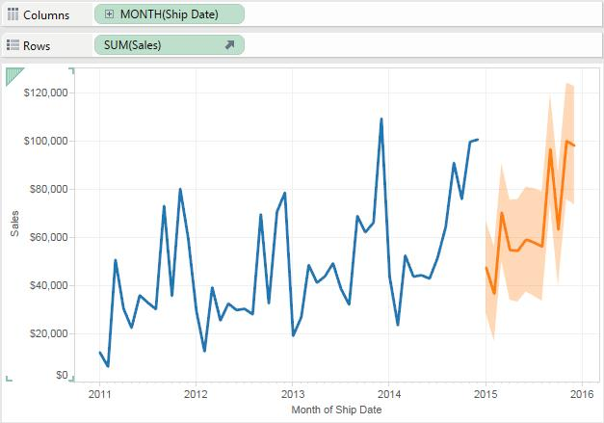

Reference Lines
Definition
Reference lines are benchmark lines added to a chart.
Examples:
- Average Sales
- Target Profit
- Maximum Value
- Minimum Value

Steps to Add Reference Line
Step 1: Create Bar Chart
- Category → Columns
- Sales → Rows

Step 2: Add Reference Line
- Go to Analytics Pane
- Drag Reference Line
- Drop on:
  - Table
  - Pane
  - Cell

Step 3: Configure
Choose:
- Average
- Sum
- Constant
- Median
Customize:
- Line style
- Label
- Color

Reference Line Example
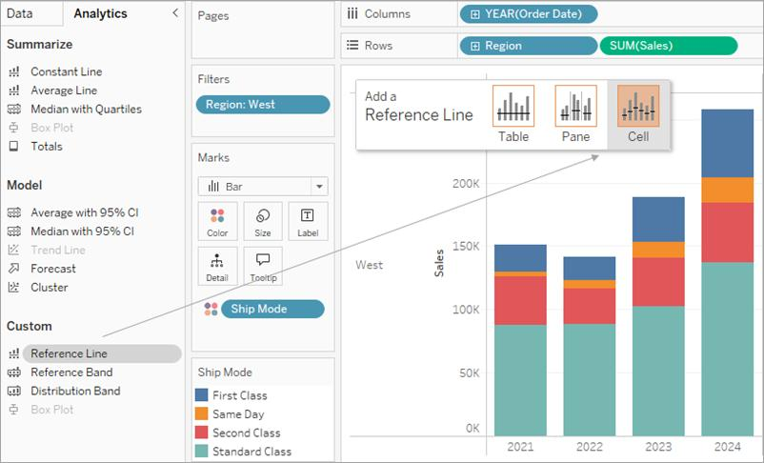
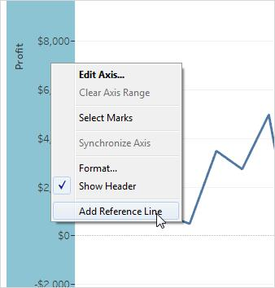
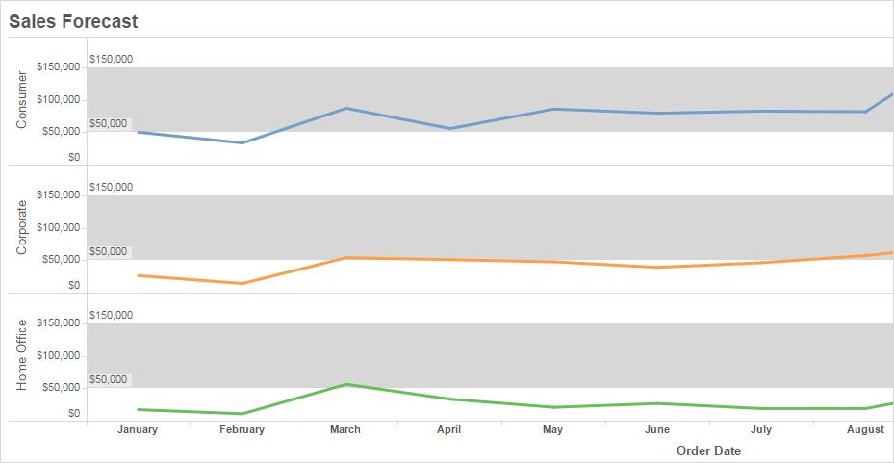

7.3 Visual Analytics in Tableau
Definition
Visual Analytics means analyzing data visually using charts, graphs, dashboards, and interactive filters.

Common Visualizations in Tableau
Visualization | Purpose
Bar Chart | Compare values
Line Chart | Show trends
Pie Chart | Show proportions
Scatter Plot | Relationship analysis
Heat Map | Density comparison
Tree Map | Hierarchical data

Important Visual Analytics Features
1. Labels
Shows data values on charts.
Steps
- Open Marks Card
- Click Label
- Check Show Mark Labels

2. Tooltips
Shows extra information when hovering.
Steps
- Marks Card → Tooltip
- Edit text and fields

3. Annotations
Used to highlight important points.
Steps
- Right-click mark
- Select Annotate
- Choose:
  - Mark
  - Point
  - Area

4. Edit Axis
Steps
- Right-click axis
- Select Edit Axis
Options:
- Range
- Scale
- Title
- Tick marks

Visual Analytics Example
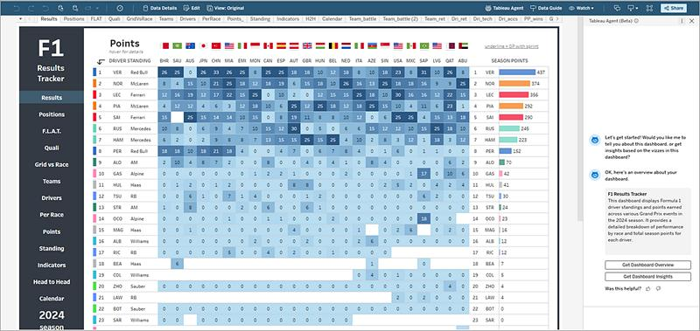
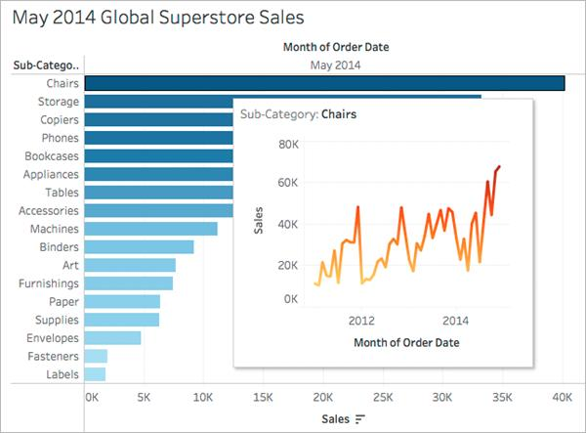
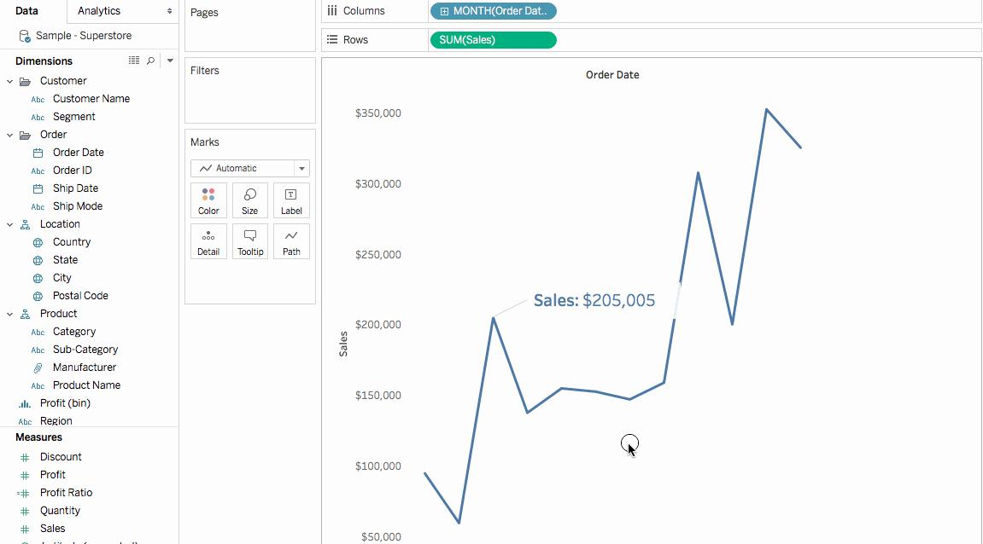
4

7.4 Forecasting, Confidence Interval, Reference Bands
Forecasting
Definition
Forecasting predicts future values using historical data.
Example:
- Future sales prediction
- Demand forecasting

Steps to Apply Forecast
Step 1: Create Time Series Chart
- Order Date → Columns
- Sales → Rows

Step 2: Add Forecast
- Open Analytics Pane
- Drag Forecast into chart
Tableau automatically predicts future values.

Confidence Interval (CI)
Definition
Confidence interval shows the prediction uncertainty range.
- Narrow interval → More confidence
- Wide interval → Less confidence
Displayed as shaded area around forecast line.

Forecast Example
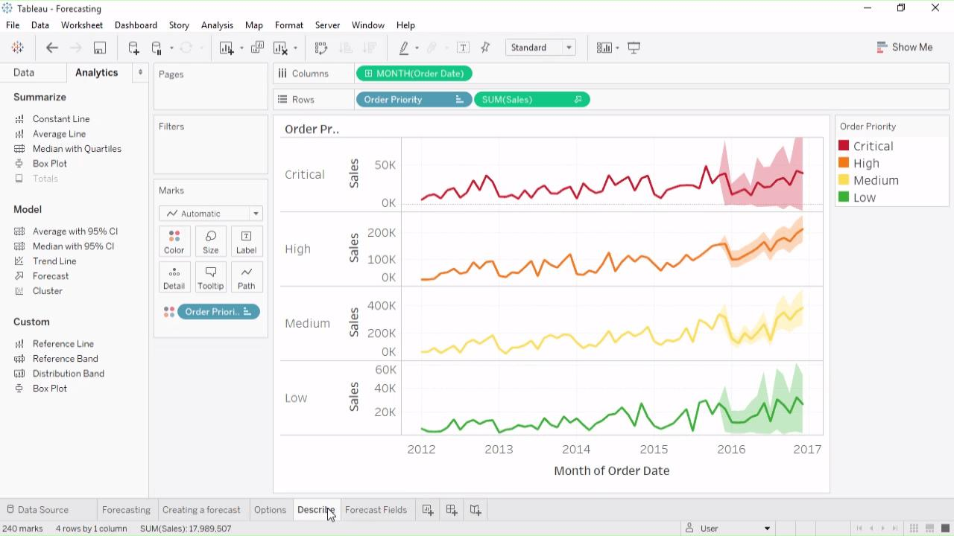
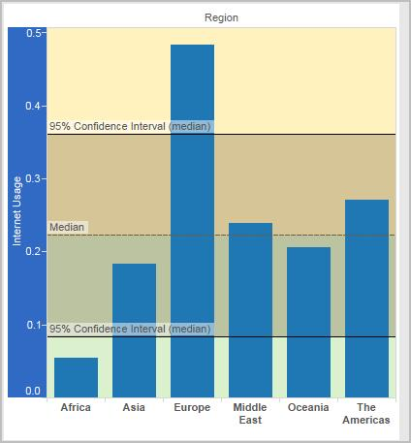

4

Reference Bands
Definition
Reference bands highlight a range between two values.
Example:
- Average to Maximum Sales
- Target range

Steps to Add Reference Band
- Analytics Pane
- Drag Reference Band
- Configure:
  - Start value
  - End value
  - Label
  - Color

Summary
Topic | Purpose
K-Means Clustering | Group similar data
Trend Line | Identify trend direction
Reference Line | Benchmark comparison
Forecasting | Predict future data
Confidence Interval | Measure prediction reliability
Visual Analytics | Interactive data analysis

